Simulation of Badminton Game in Matlab and GeoGebra

**List Of Content**

1. Acknowledgement
2. Introduction
3. History
4. Physics and Mathematics behind the game
5. Analysis of different shots in the game
6. Trajectories
7. Pictures of the origami
8. Pictures of the plotted shuttlecock in Geogebra
9. Simulations of the Game(Aattached File in Geogebra format)
10. Hawkeye techinque used in the game
11. Equation Analysis of shots in 3d game of badminton
12. Comclusion
13. References

**Acknowledgement**

We would like to express our special thanks of gratitude to our  teacher Rishi Asthana who gave us the golden opportunity to do this wonderful project on the topic **BADMINTON** which also helped us in doing a lot of Research and we came to know about so many new things we are really thankful.

**Introduction**

Badminton is a worldwide sport and it’s also the fastest racket sport. Measurements of the

badminton shuttle shows that it can travel at nearly 500 km/h [1]. The shuttle is made from goose

feathers to give its aerodynamic properties and cork to transfer the kinetic energy of the racket to the shuttle. The properties of a shuttle are difficult to define due to the lack of research on how it behaves.There is no exact definition of how the shuttle should be designed or even its properties. This slows down the development of the market by making it less competitive.

To determine the desirable properties of a shuttle there should be a lot of testing and calculations

from an engineering point of view. The desirable properties of a shuttle are considered to be how a shuttle rotates, tumbles and how the trajectory goes. By identifying and quantifying these desired properties a standard shuttle can be determined. By testing the shuttle in many ways, the different properties can be identified, but this is not an easy process. In this report, some of the properties will be monitored and analysed. One of the most interesting properties is the deviation inside ways direction due to the rotation of the shuttle which is the main focus of this report.

**History**

The General population of china played an amusement in around fifth Century, known as ti jian zi. This had an importance which legitimizes the ongoing interaction i.e. 'kicking the van'. The goal of the amusement is to keep the van over the ground utilizing a high quality racket. After numerous cases and conclusions, It was viewed as the main diversion that utilizes a Van.

After some time it was played with an alternate name i.e. Battledore and Shuttlecock in china, Japan, India and Greece. To play this diversion you utilize an oar to hit the Shuttlecock forward and backward. By the sixteenth century, it has turned into a mainstream amusement among youngsters in Britain. In Europe this diversion was known as jeu de volant to them. It ended up famous in India as POONA. This amusement is much similar to the Battledore and Shuttlecock yet with an additional net. The English armed force learned and took this amusement back to their Home grounds.

In 1873, In a garden party held by Duke of Beaufort Poona was played and as it was fun, it ended up famous among the English society's world class. What's more, now it got its celebrated name 'The Badminton diversion'. In 1877, the Shower Badminton Club was shaped and built up the principal official arrangement of tenets.

**Physics and Math Behind the Game**

1)Drag - rubbing between a strong question traveling through either fluid or gas, which restricts the movement of the protest.

2)Momentum - the propensity of a question move toward its of movement.

3)Tension - a response constrain connected by an extended string on the items which extend it

4)Velocity - rate of progress of position along a straight line regarding time

Rackets Shuttlecock (Feathered creature)

A shuttlecock is a high-drag shot with an open conelike shape. The cone is framed from sixteen covering plumes implanted into an adjusted plug base.

Plastic(Nylon) transports are frequently used to diminish their expenses as feathered transports break effortlessly.

Material science in Shuttlecock

The shuttlecock is intended to be steady in flight, with its symmetrical shape. The quills or plastic wings/skirt behind the stopper are what help settle the flight. Be that as it may, if these are destroyed, the birdie won't fly appropriately. Efficiently, the van is intended to be a high-drag shot. The explanation for the skirt, and the high drag is so the shots won't be fast to the point that it is unmanageable. Likewise, because of this drag, the bus goes in a parabola, including the power of gravity when it begins falling toward the ground.

Material science BEHIND THE Game

Badminton is where players score focuses by hitting a shuttlecock with their racquet so it ignores the net and terrains in their rivals' half of the court.

It includes different parts of material science, for example, streamlined features, shot movement, motor/potential vitality, and so on.

Badminton rackets are lightweight, made out of various materials running from carbon fire composite to strong steel. These racquets are made to make spry swings with adaptability and mass to enable energy and strain to deliver different shots.

Material science in Racquets

Strain of the racquet is significant in badminton. The versatility and adaptability of the strings help with speed of the shot. This fun impact can help regarding speed, however a few players think that its more troublesome in controlling shots, as the additional skip is once in a while difficult to control. A higher pressure of strings results in quicker and snappier control in shots. While bring down strain results in a bouncier shot (greater flexibility)

For the swing of the racquet, the force must be adequate to defeat drag, which is the reason badminton racquets are thin and light. This enables players to swing with more prominent speed. The plan of the badminton racquet was made principally so players can swing with more speed and to have enough force to counter drag and hit the bus quick smash.

**Analysis of Different Shots in Game**

**Defensive badminton shots**

The Clear Shot

In this stroke, contact the shuttlecock around the center of your racket head. The point of the reasonable is to make the bus go up high noticeable all around and arrive at your adversary's back court .This is utilized when you have to purchase more opportunity for yourself to come back to base before the following return. It is likewise vital to utilize when your rival is close to the fore-court, compelling him to withdraw to the back to recover the van.

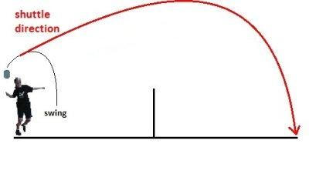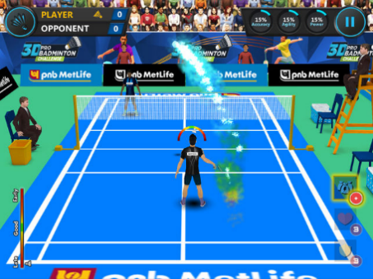

The Drive Shot

The drive shot is a basic flat shot, directly hit over the net. It is a powerful, quick counter-attacking shot that is easy to execute. Your racket should be held with the head facing straight ahead.It can sometimes be strategic to aim the shot at your opponent who will be unable to react or shift his body in time as their natural reaction will be to duck the shot.

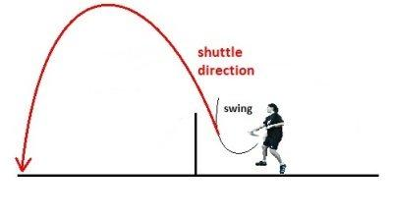

**Offensive badminton shots**

The Drop Shot

The drop shot is best utilized when the van is going towards you in the main portion of your court. To play out this stroke, the player must hit the bus rooster downwards towards the adversary's fore-court, going for it to go right over the net. You need to make it resemble a drive, yet rather you just utilize a little power to push the bus over the net. This shot is key to utilize when the rival is close to the back court, foreseeing your stroke to be a reasonable or drive.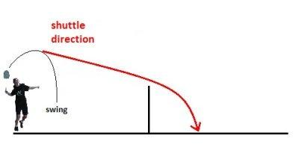

The Smash Shot

The badminton crush is viewed as the most amazing shot in badminton and you can consider it like a drive that is calculated downwards. It is best utilized when the van when its high noticeable all around, so it very well may be calculated downwards.When the bus roll in from a high edge, it will enable you enough time to curve and get in position to strike. At the most astounding purpose of contact, with a flick of the wrist point the bus downwards in a lofty slope.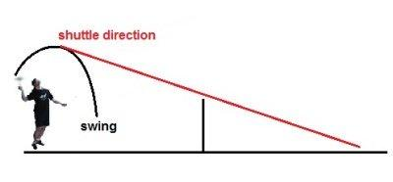

**Trajectories of Shuttlecock**

The direction of a badminton carry is portrayed in Figure 1. The figures incorporate the entirety

direction and the finish of every direction is the point at which the van hits the floor. In Figure 1a the situation from the hit of the racquet is depicts as a projection on the floor and forward, which is set as the x bearing.

In Figure 1b the sideways deviation is depicted with positive greatness to one side seen

from the hitter, which is set as the y-course.

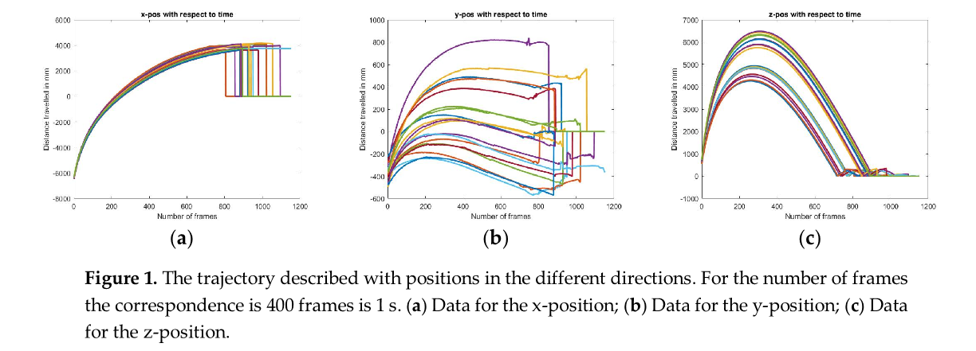 Note that the charts don't begin at zero however the state of the direction is free of the beginning stage for both x-and y-heading. In Figure 1c the stature of the direction is depicted with a beginning stage close over the floor, which is set as the z-course. The time scale is portrayed with edges from the information, 400 casings compare to 1 second. As observed is in Figure 2a the information for speed in the y-bearing is exceptionally loud because of estimation vulnerabilities. In this way, the bend fitting imagined in Figure 2b was should have been ready to dissect the related properties. This was shockingly by all account not the only issue with the information. Because of that tests are difficult to repeat precisely, for each attempt the underlying qualities were extraordinary. This is dependably an issue when the human incorrectness is available. To lessen this vulnerability positions and speeds were just characterized by the directions shape. This makes the qualities on pivot in the plots less intriguing at times. Be that as it may, when attempting to comprehend the overseeing properties this has no effect. To dispose of the human error the directions where moved to the equivalent gazing point, the source of the plots was picked as the beginning stage, and a point after a brief timeframe was coordinated to kill the distinction in beginning edge. The speeds were controlled comparatively to have the capacity to think about them. In Figure 3 a few properties of the direction are portrayed. These plots depend on bend fitted qualities with leftover qualities as near 1 as could be expected under the circumstances. The lingering estimation of 0.83 was gotten by fitting the y-speed to a polynomial of degree four.

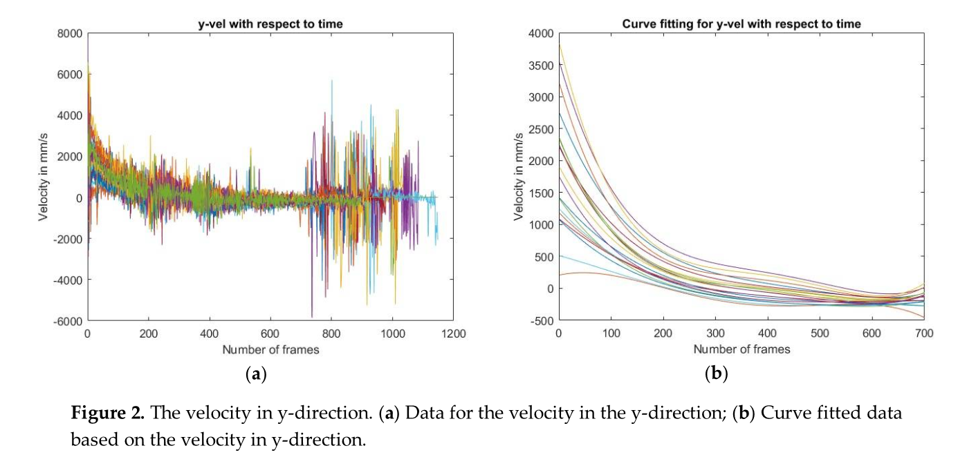

Figure 3 imagines how the y-speed is influenced by its situation in the direction. The diagrams relate to a similar transport yet extraordinary attempt outs. The distinction compares principally to a distinction in beginning speed. It's hard to dispose of this distinction between the attempt outs and still have the capacity to recognize different properties. In this way, the distinction in beginning speed is something to consider through the investigations.

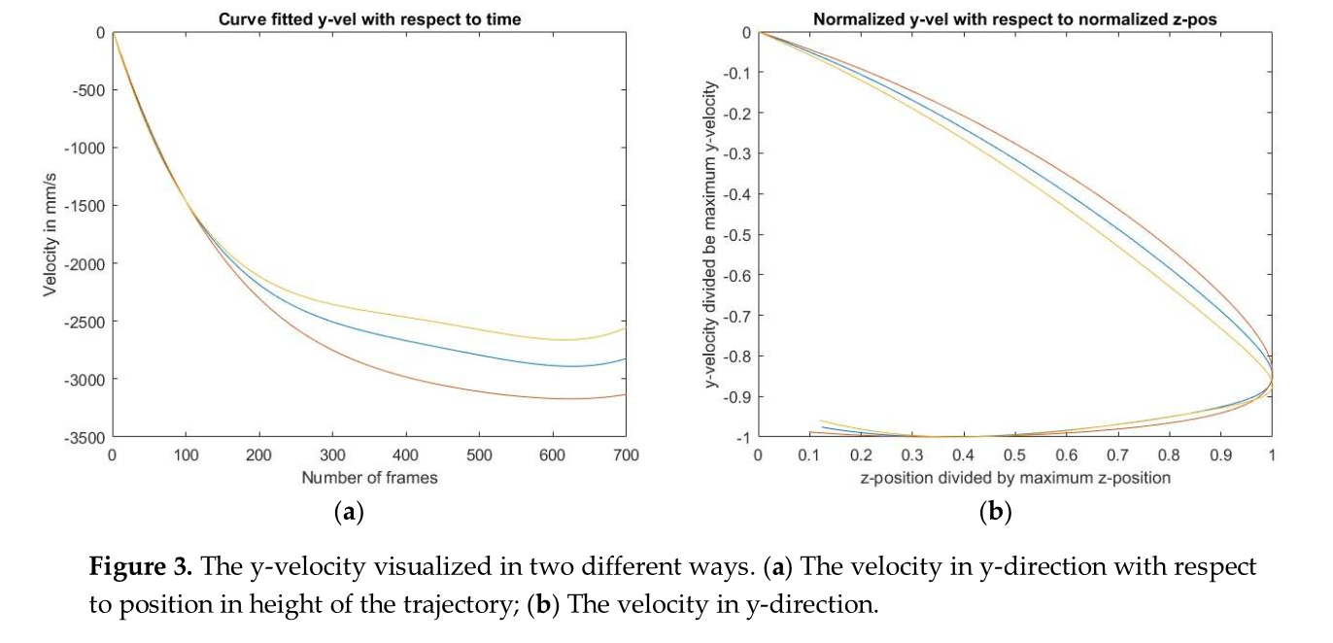

The conduct while making up for everything with the exception of the beginning y-position is imagined in Figure 4a. The figure demonstrates indisputably the sideways deviation of the direction. The deviation has a negative subordinate which implies that the difference in the direction influences the van to go to one side. In Figure 4b the speed in y-heading is plotted standardized with the speed extent. The speed is negative since it is in negative y-course. The standardized speed relates to an offer of the aggregate speed. The offer ends up more noteworthy and more noteworthy in the initial segment of the direction. This can be identified with the turn of the bus.

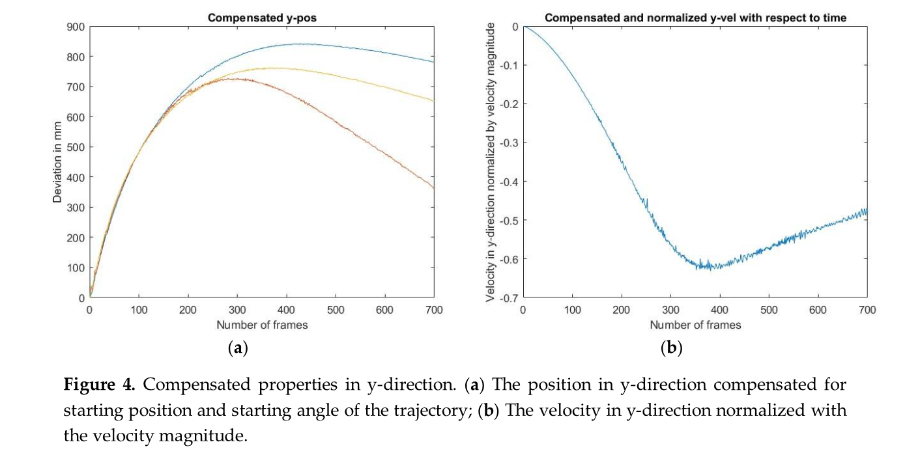

**Pictures of the Origami**

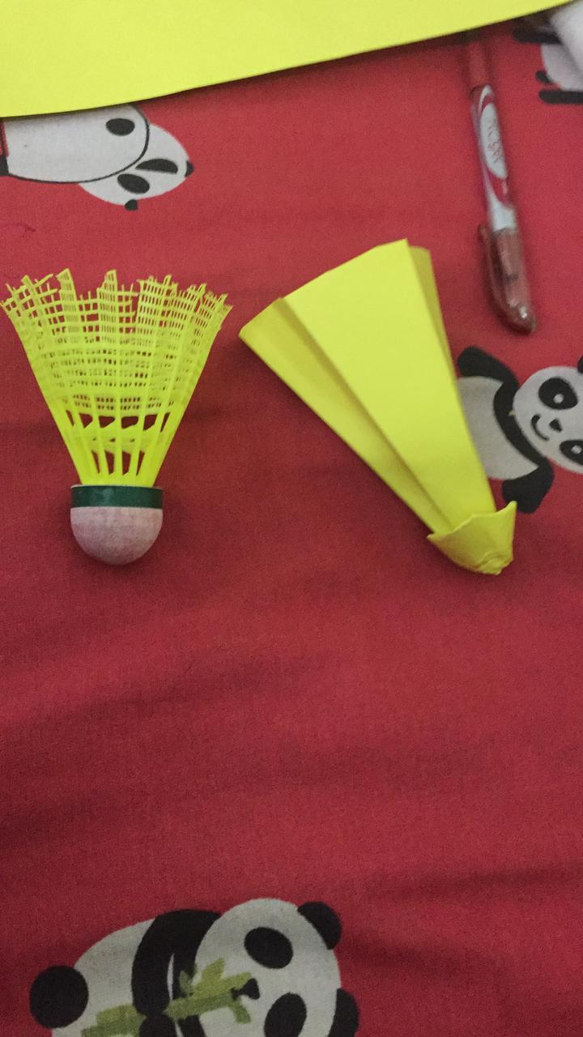

**Pictures of the Shuttlecock Plotted in Geogebra**

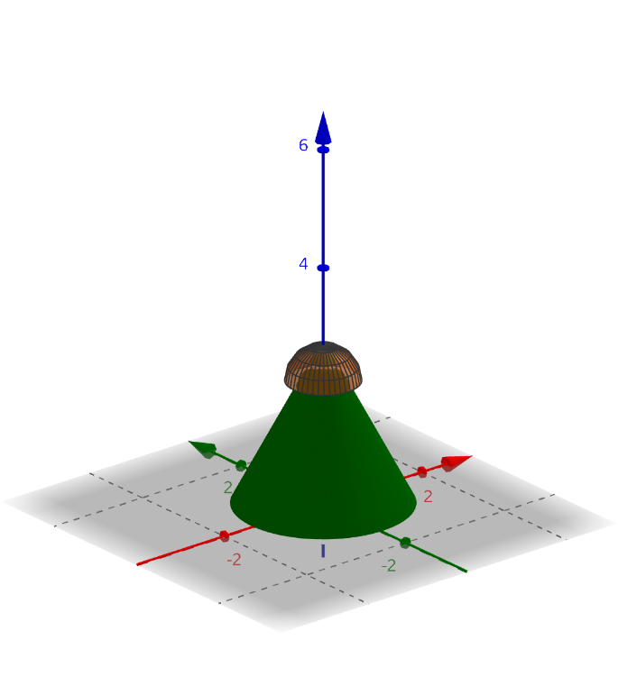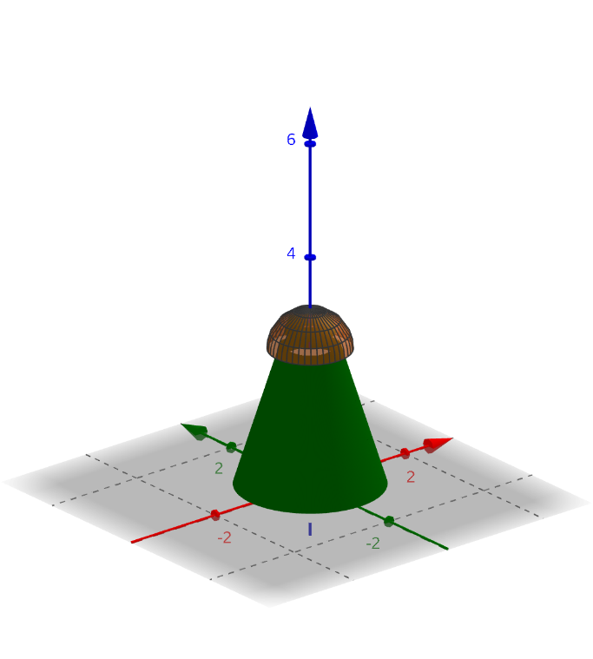

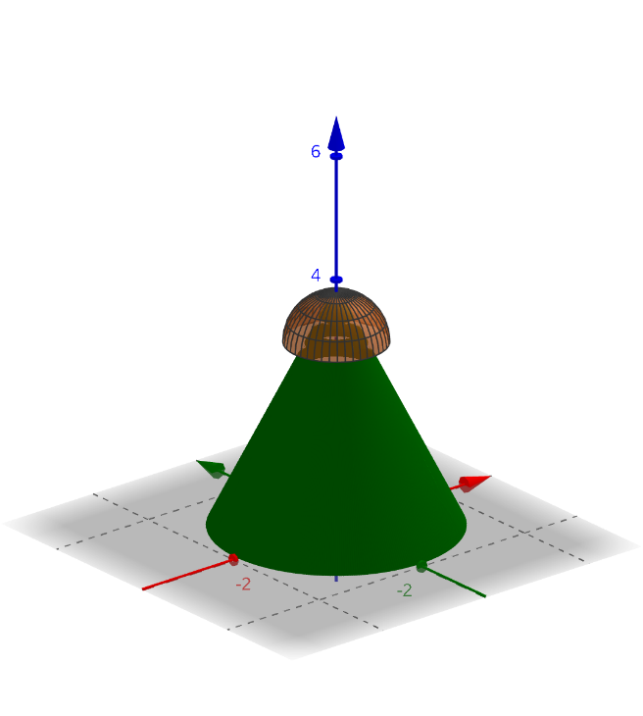

**Hawk Eye Techinque**

At the present time, the hawkeye framework in badminton is fundamentally the same as what it is in tennis. It comprises of various fast cameras associated with one another and to a unified PC framework by means of fiber optic links. The pictures taken by the cameras are encouraged to the PC framework which ascertains/reproduces the direction taken by the cockerel. The cameras have a two second cutoff window in which the administrator can initiate the hawkeye. This gives enough time for the administrator to trigger the framework as the cockerel arrives out or near the lines.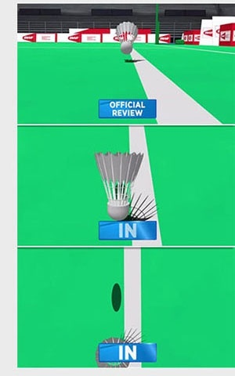

There are some problems faced by this system though.

* The shuttlecock is extremely light (~5g) and is easily deflected by the slightest wind. It becomes tough to calculate the exact path of the cock by a computer simulation.
* The computer simulation of the shuttlecock is designed to take into account only diagonal landings of the cock. However, the cock might even land vertically, and the computer simulation still assumes it to be traveling diagonally. This may result in an out call when the cock landed in.

**Equation Analysis of shots in 3d game of badminton**

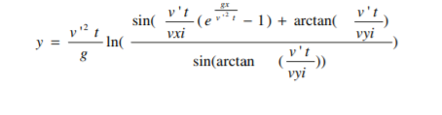

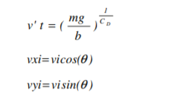 

**For Trajectory of**

* **Clear Shot Vi = 45 m/s ,** θi = 0 degree
* **Smash Vi = 70 m/s ,** θi = -10 degree
* **Drop Vi = 25 m/s ,** θi = -20 degree
* **Fast Overhead Stoke Vi = 56 m/s ,** θi = 30 degree

**Conclusion**

This report raises the inquiry concerning properties of badminton transports. Truth be told, there are many further investigations that can be made with respect to these and comparable properties. The objective in long haul is characterize the standard transport. The properties of this van should profit the players and the game in issues of interactivity—remembering that distinctive natural conditions possibly requires diverse properties of the van. Besides, it's vital to comprehend the conduct of transports is relying upon pneumatic stress and temperature. In the event that all conditions are viewed as each player can rehearse with indistinguishable conditions from there are on the competitions. At the point when the standard transport is characterized, the genuine scan for a manufactured comparable can begin. The inquiry has just started however it's hard to get an ideal outcome without the definition.

**Reference and Bibliography**

References  
Tension, momentum, drag, and projectile  
(http://physics-badminton.weebly.com/the-physics-behind-everything.html)  
Kinetic energy, potential energy, gravitational energy   
(<http://sportyphysics.blogspot.ca/p/physics-concept>.

Hawkeye.com(For the hawk eye technique)

SURFACE AREA AND VOLUME OF THE SHUTTLECOCK

